**The general framework in first 150 lines**

* **settings of important parameters**

These parameters are divided into two different categories. One is set for simulation and the other one is set for data storage.

* 1. **Settings for simulations**
     + Simulations time: it means the length of simulation
     + Assignment iterations: it need to count the number of iterations of assignments for further calculations
     + Interval: it means a certain time spent in this simulation. In these codes, it would simulate once per 6 mins.
     + Start time/interval: start time/interval of this simulation
     + End time/interval: end time/interval of this simulation
     + Convert between interval and time: it is necessary to be considered for coding.
  2. **Settings for data structure**
     + Nodes: how many nodes in this network
     + Links: how many links in this network
     + Agents: how many agents in this network
     + Arrivals: counts the cumulative arrivals
     + Departures: counts the cumulative departures

List/dictionaries are used as the key data structure.

Some mapping relations need to be considered to link external node numbers and internal node sequence no. External nodes can be referred in a large range (e.g. 10001) and internal node sequence numbers should start from 0 to the number of nodes.

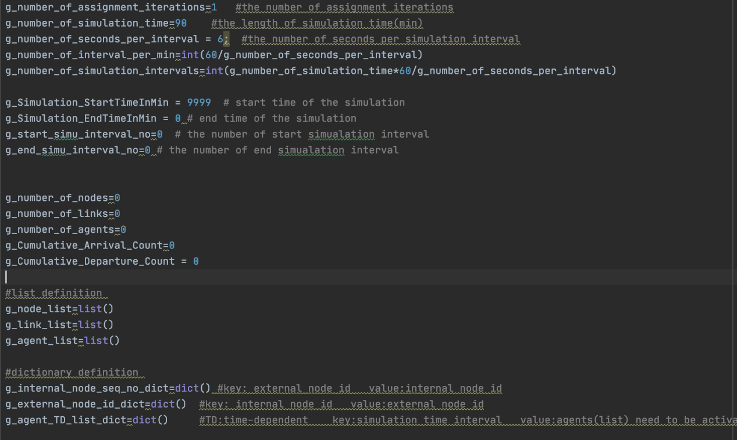



Figure 1 Parameters setting

* **Class Definition**

“Class“ contains two member functions at least. One is for self-feature definition and the other one is for variable initialization.

1. **Class Node**
   * + Self- feature: node id; map-relation between self and external nodes for data conversion; relations between nodes and links (incoming-link & outcoming-link)
     + Initialization: establish mapping relation between external node id and internal node id
2. **Class Link**
   * + Self- feature: similar to GMNS format
     + Initialization: there is something need to be noticed which is link cost updating. And other initializations are presented in codes.



Figure 2 Characteristics for links

1. **Class Agent**
   * + Self- attributes: (Figure3)
     + Initialization: it is for updating agents and calculating queues between arrival and departure in each link.

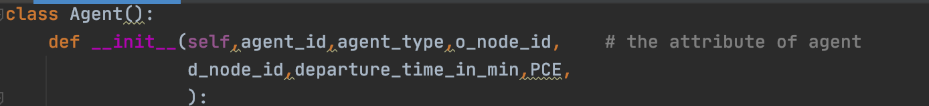

Figure 3 Characteristic for agents

* **Convertion between absolute time and relative time.**

Absolute time is 24-hour time world time and relative time is internal time in simulation (starting from 0 to the horizon of simulation, say 60 min).

**Global data**

It is necessary to define global variables across difficult functions (Figure4).

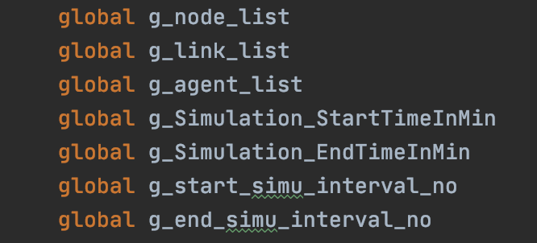

Figure 4 global variable definition